Computer vision hw1

B05902050

黃子源

Part1:

I use python PIL to complete part 1.

In my program, I use function getpixel() and putpixel() to get the value of every pixel.

1. Upside-down lena.im  
   I exchange the up side pixels of the picture with the down sides, and save it as lena2.bmp.  
   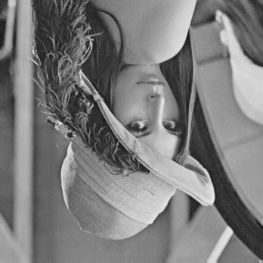
2. Right-side-left lena.im  
   I exchange the left side pixels of the picture with the right sides, and save it as lena3.bmp.  
   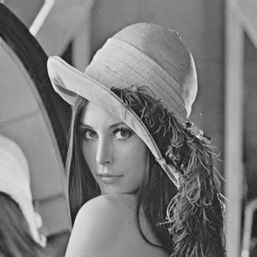
3. Diagonally mirrored lena.im

I exchange the up-left side pixels of the picture with the down-right sides, and save it as lena4.bmp.  
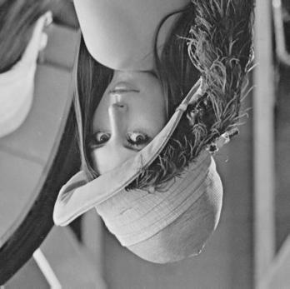

Part2:

I use photoshop cc2018 to do the works below.

1. Rotate lena.im 45 degrees clockwise:   
   點選右上角“影像”🡪 影像旋轉 🡪 任意 🡪 調整成45度順時針  
   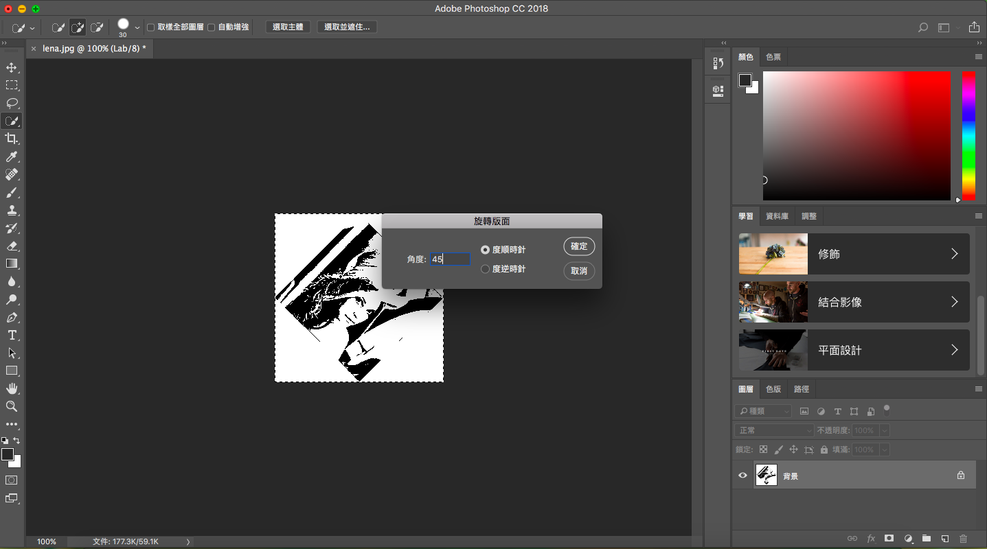
2. Shrink lena.im in half:  
   點選右上角“影像”🡪 影像尺寸 🡪 把影像的長寬都調為原來的一半  
   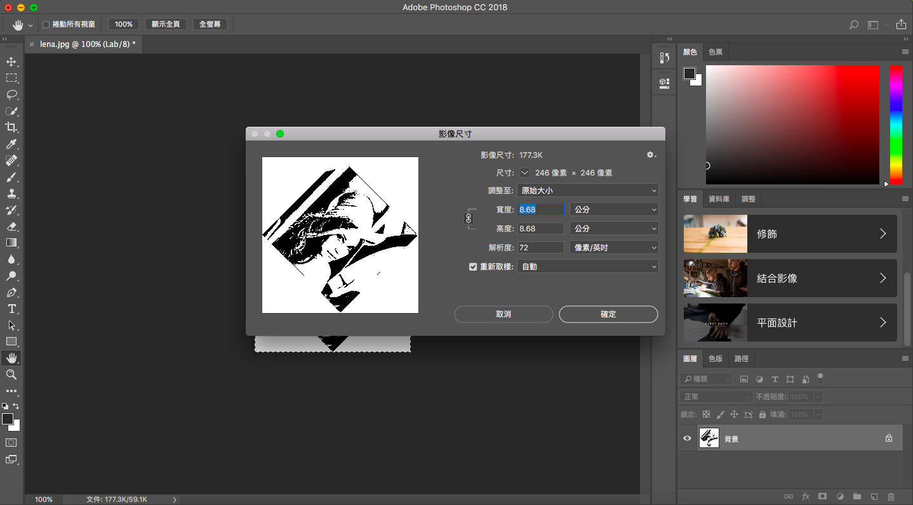
3. Binarize lena.im at 128 to get a binary image:  
   點選右上角“影像” 🡪 調整 🡪 臨界值 🡪 把臨界值調成128  
   